 **“2025 *Kiwanis Sap Run for Kids*”**

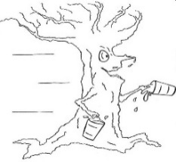

**Saturday, April 26th, 2025 Rivermill Park, Huntsville**

**Races: 9:00 AM (ages 3-7) * 9:15 AM (ages 8-13)**

***The Kiwanis Sap Run is a ‘fun & safe event’ in the heart of Huntsville and kicks off “Muskoka Maple Festival”***

***Everybody has fun, entrants all receive their awards courtesy of Windmill Bakery & Bistro and then can enjoy a yummy pancake breakfast courtesy of Rotary- People of Action.***

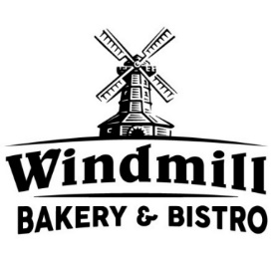   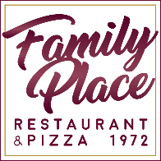

**Pre-Registration via muskokamaple.ca $10/runner**

**( Payable through Eventbrite)**

**Day-of Registration on site $15/runner**

**Cash or E Transfer to; treasurer@huntsvillekiwanis.ca**

  **Credit or DEBIT…and payment through “SQUARE”**